Install Guide

**Requirement software: SQL Server 2008, IIS 7.5, VS 2010**

* **Step 1: Configuration IIS 7.5**
  + Open IIS7.5
  + Right-Click on [Default Web Site]. Choose [Add Application]
  + Alias: Cookery and Physical Path point to Directory of Website
  + Click OK
* **Step 2: Configuration Permission.**
  + Open Windows Explorer
  + Go-to directory of Website, Right-Click and choose Properties
  + Click Edit button on Tab Security
  + Click Add and type “IUSR, IIS_IUSRS” without quotation in the textbox
  + Give IUSR and IIS_USRS full control then click OK
  + Click OK again to close the Properties windows
* **Step 3: Creating & configuration database.**
  + Open file “E-Project Cookery.sql” with SQL Server 2008
  + Execute the code from the beginning to point 1
  + Open Visual Studio Command Prompt
  + Type “aspnet_regsql” without quotation to open ASP.NET SQL Server setup wizard
  + Click Next two times and type “Cookery” without quotation to the Database Combo-box
  + Click Next two times again. After the process complete. Close the Visual Studio Command Prompt Windows
  + Back to Sql Server 2008, Execute code from Point 1 to Point 2
  + Open IE and type <http://localhost/Cookery/user/> to the address
  + Go-to Register Section and register 5 members: jame, admin, member1, member2, member3
  + Open Website with Visual Studio 2010
  + Click Asp.Net Configuration from Website on the menu
  + On tab Security, click Manager Users
  + Click Edit Roles, and give role Admin to Admin user
  + Click Edit Roles, and give role Owner to Jame user
  + Back to Sql Server 2008, Execute code from Point 2 till end

1. **Step 1: Configuration IIS 7.5**

Open IIS 7.5

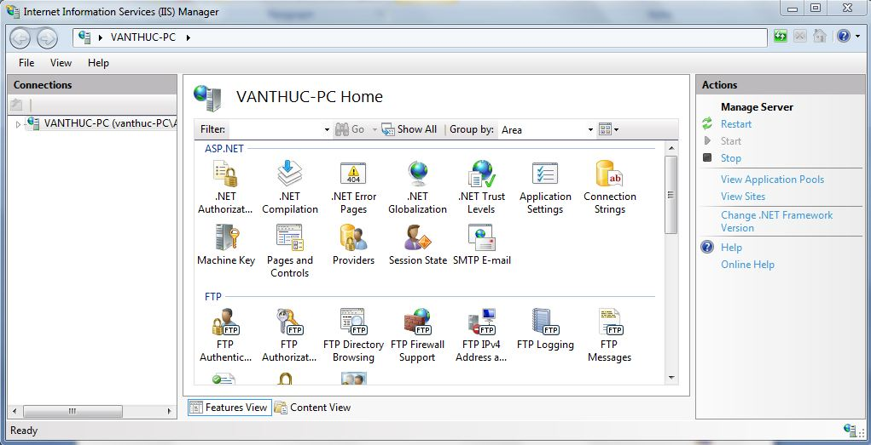

Right-Click on [Default Web Site]. Choose [Add Application]



Alias: Cookery and Physical Path point to Directory of Websit



Click OK

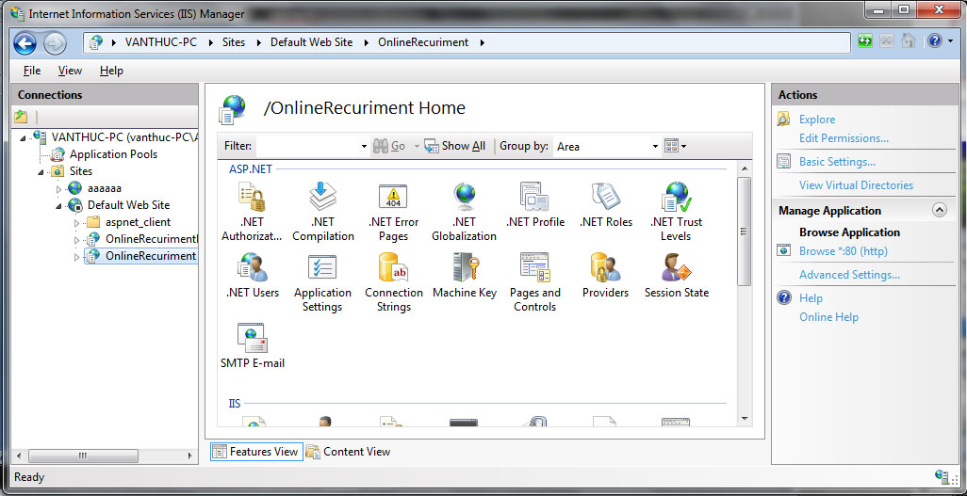

1. **Step 2 : Configuration Permission**

Open Windows Explorer

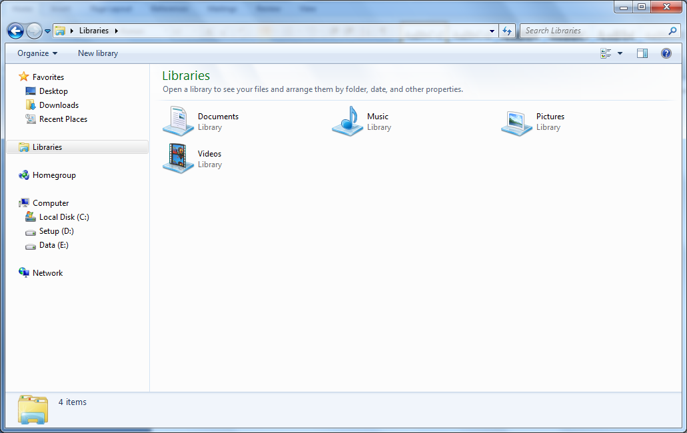

Go-to directory of Website, Right-Click and choose Properties

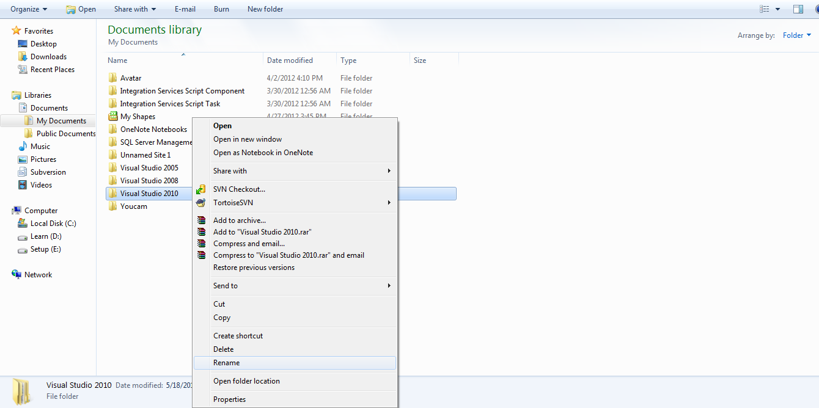

Click Button Security

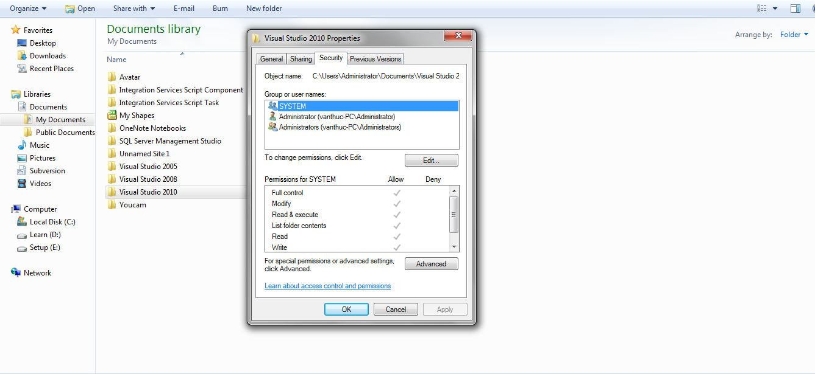

Click button Edit…

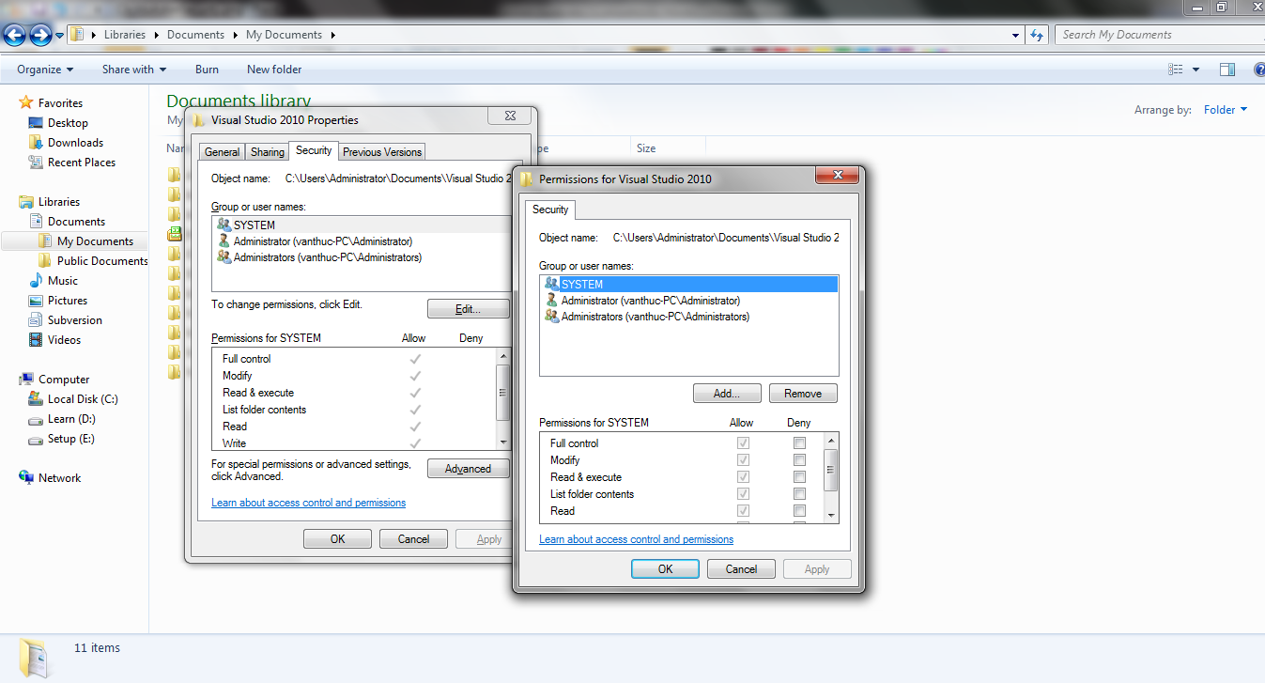

Click Add and type “IUSR, IIS_IUSRS” without quotation in the textbox

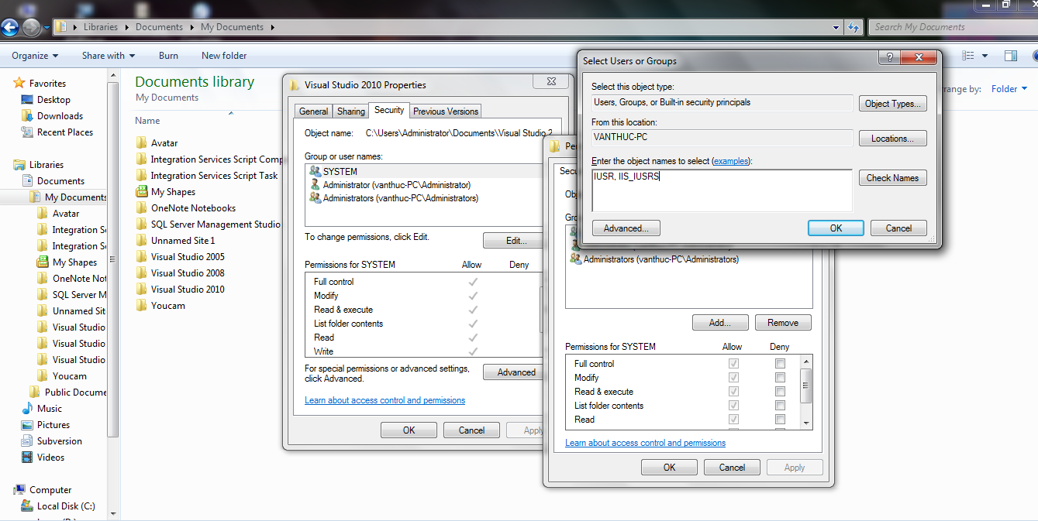

Give IUSR and IIS_USRS full control then click OK

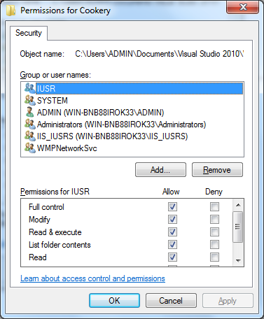

Click OK again to close the Properties windows.

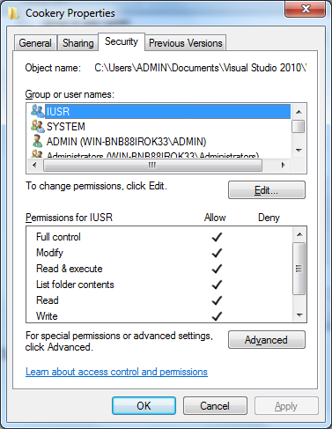

1. **Creating & configuration database**

file eProjectSem3.sql with SQL sever 2008

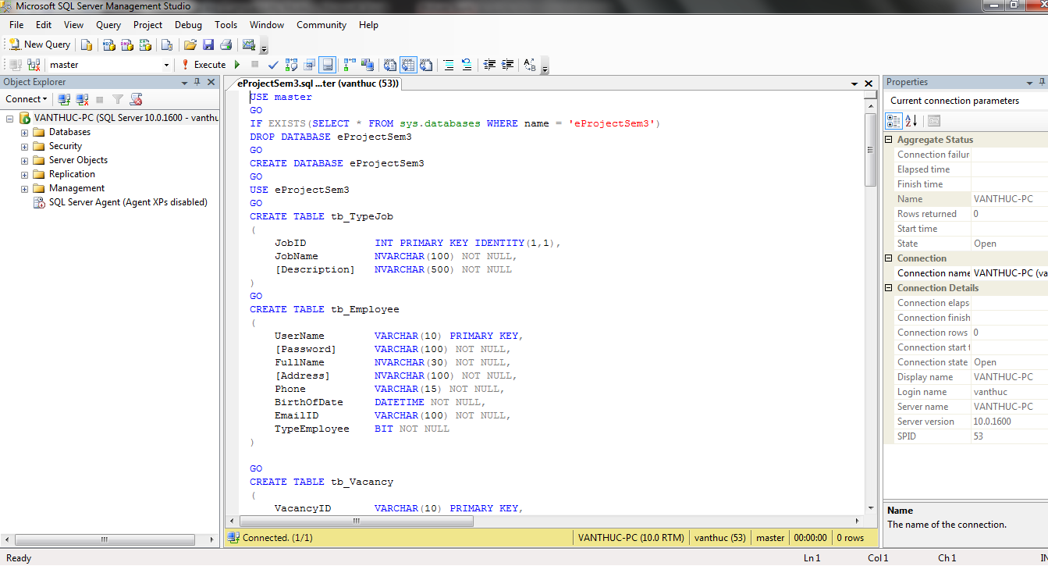

Execute code on file 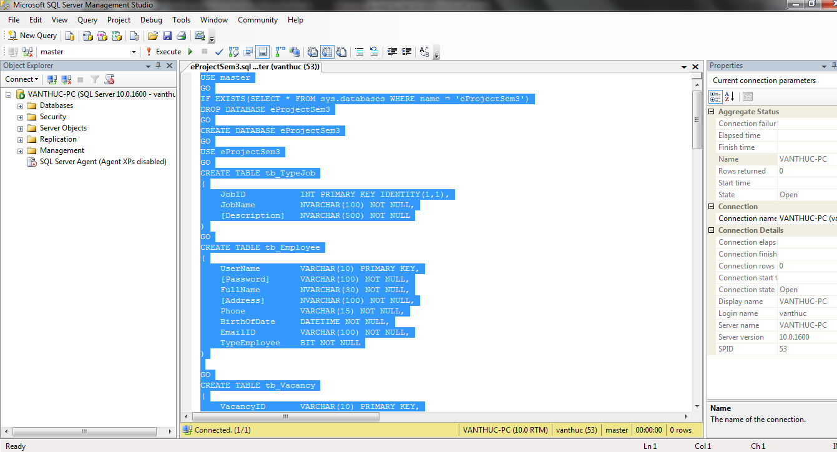

Open file Proceduce_HungDN.sql with SQLSERVER 2008 and Execute this code

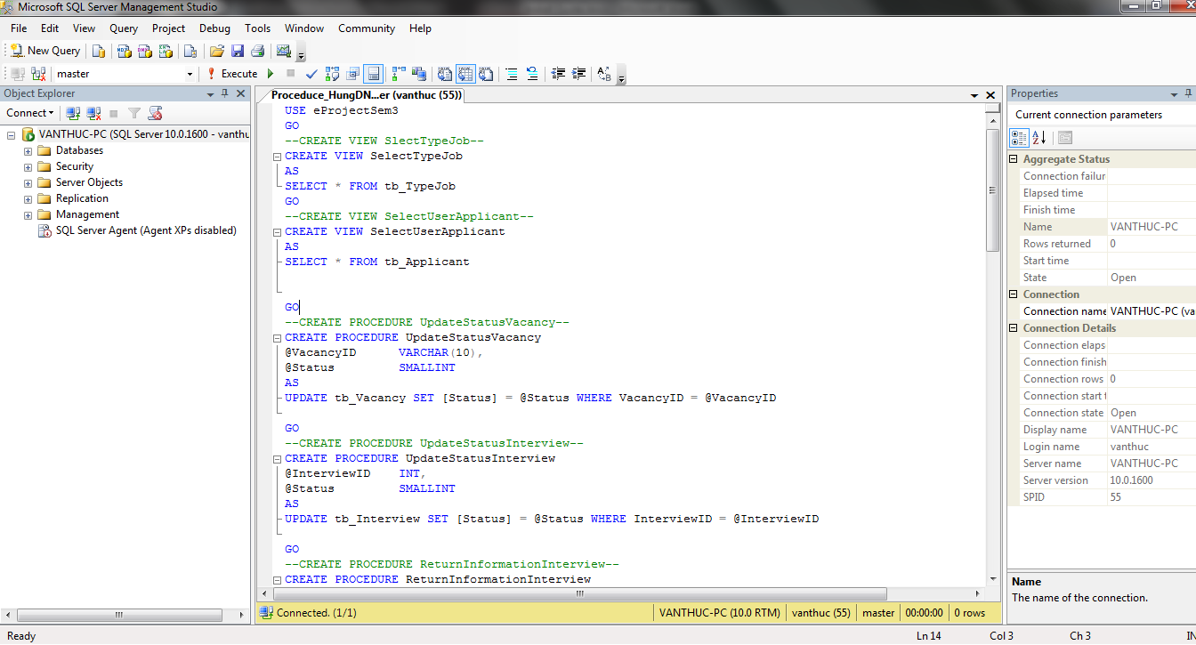

Open file Procedure_DungVM .sql with SQLSERVER 2008 and EXECUTE Code

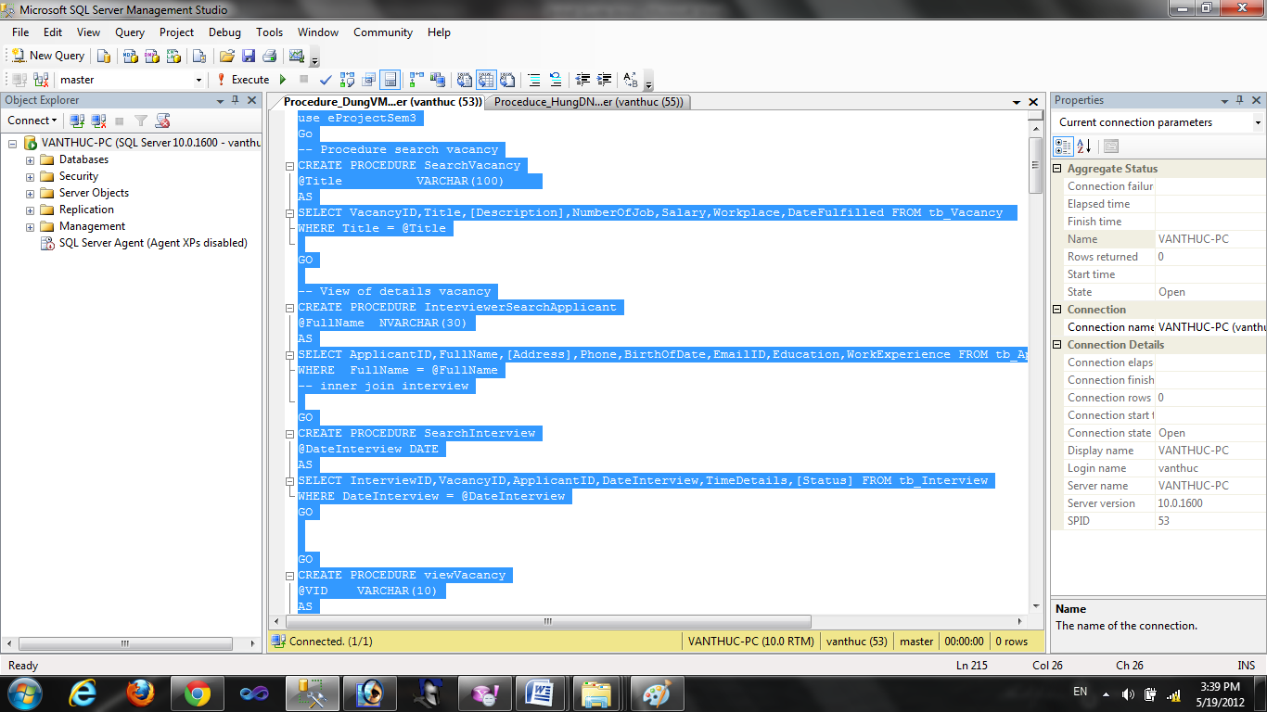

Open file Procedure_HoangLP.sql with SqlServer2008 and EXECUTE

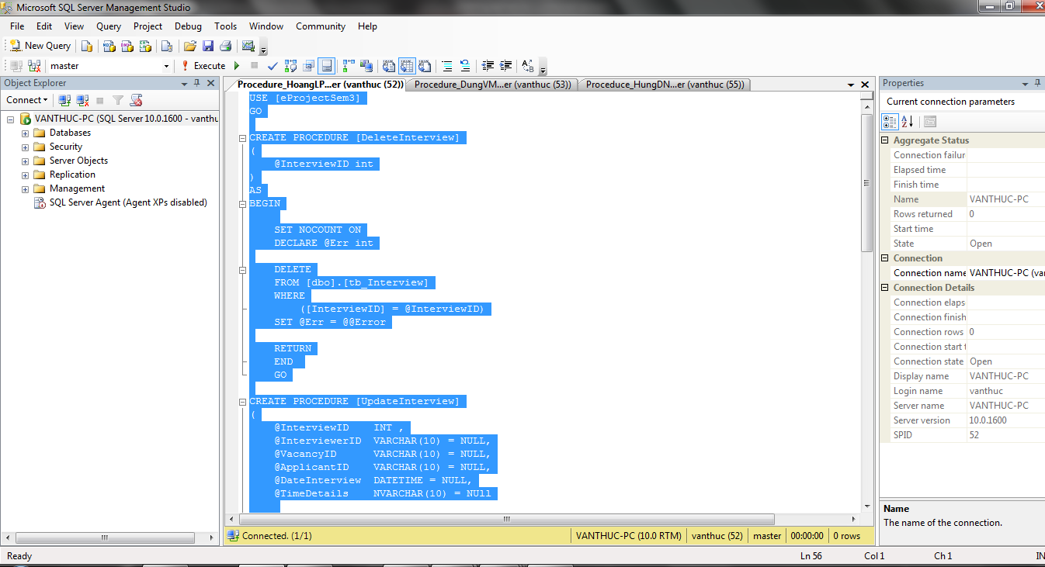

Open file ThucStoreProcedure.sql with SQLSERVER 2008 and EXECUTE this code

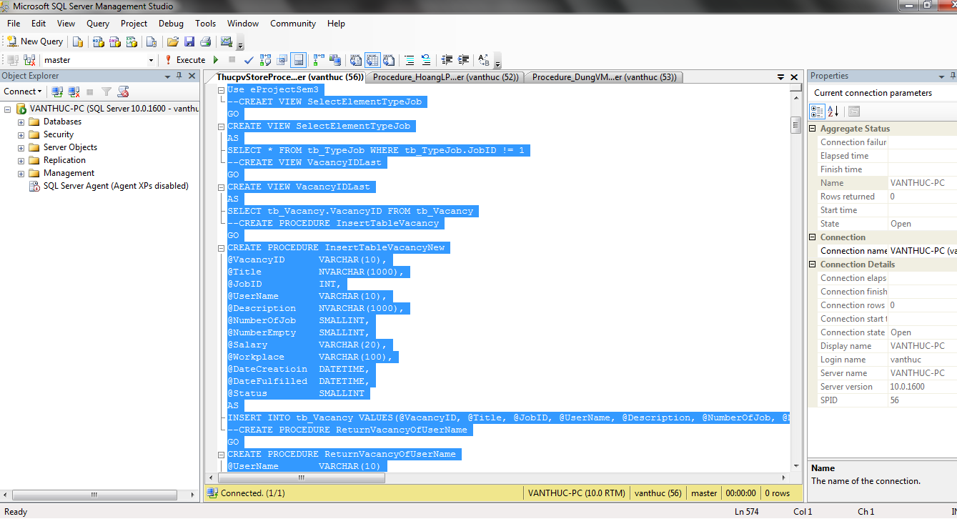

Open Visual Studio Command Prompt

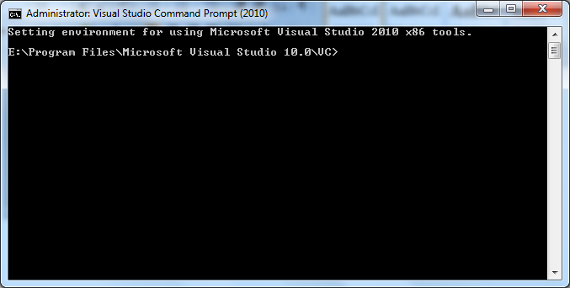

Type “aspnet_regsql” without quotation to open ASP.NET SQL Server setup wizard

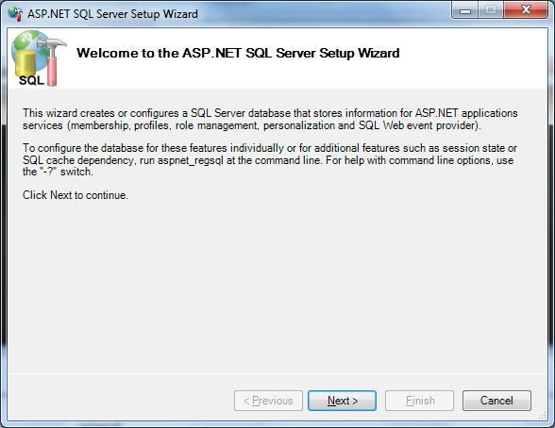

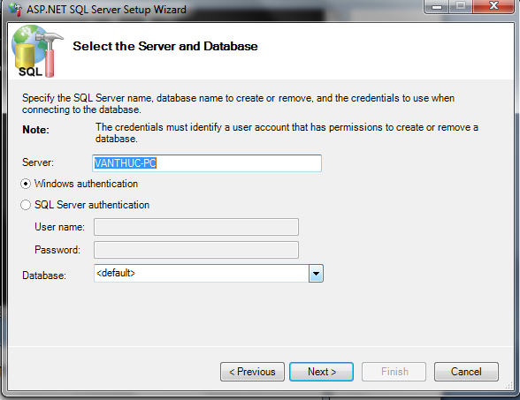

Choice eProjectsem3 in Database combobox

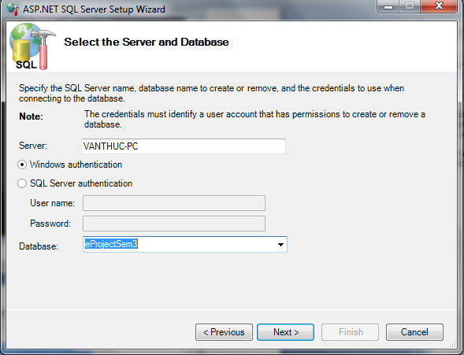

Click Next two times again. After the process complete. Close the Visual Studio Command Prompt Windows

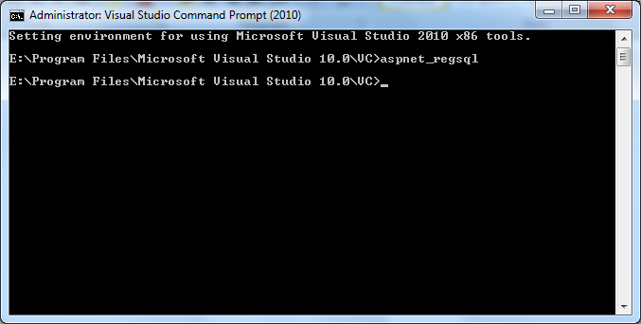

Open IE and type http://localhost/OnlineRecuriment/Home.aspx to the address

